**ADGISA - Lab 01 - Computer Setup**

Aidan Brown

Sept 05, 2023

1. Screen capture of the mapped drives on your local computer - in File Explorer show the various drives (network locations) you are now connected to: U and V:

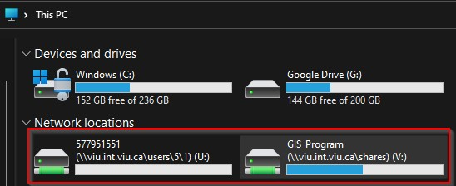

1. Screen capture of a saved file on the U drive - save a file (could be the Word file you are creating) on the U drive and show it's path (shown at the top of File Explorer) to confirm you are able to write to the U drive:

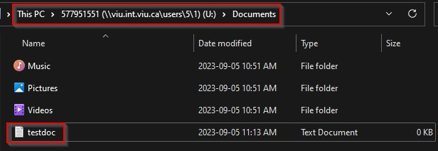

1. Screen capture of the ArcGIS Pro interface on your local computer - Programs > ArcGIS > ArcGIS Pro. Just an empty project will suffice, but make sure your login credentials are shown in the top-right corner:

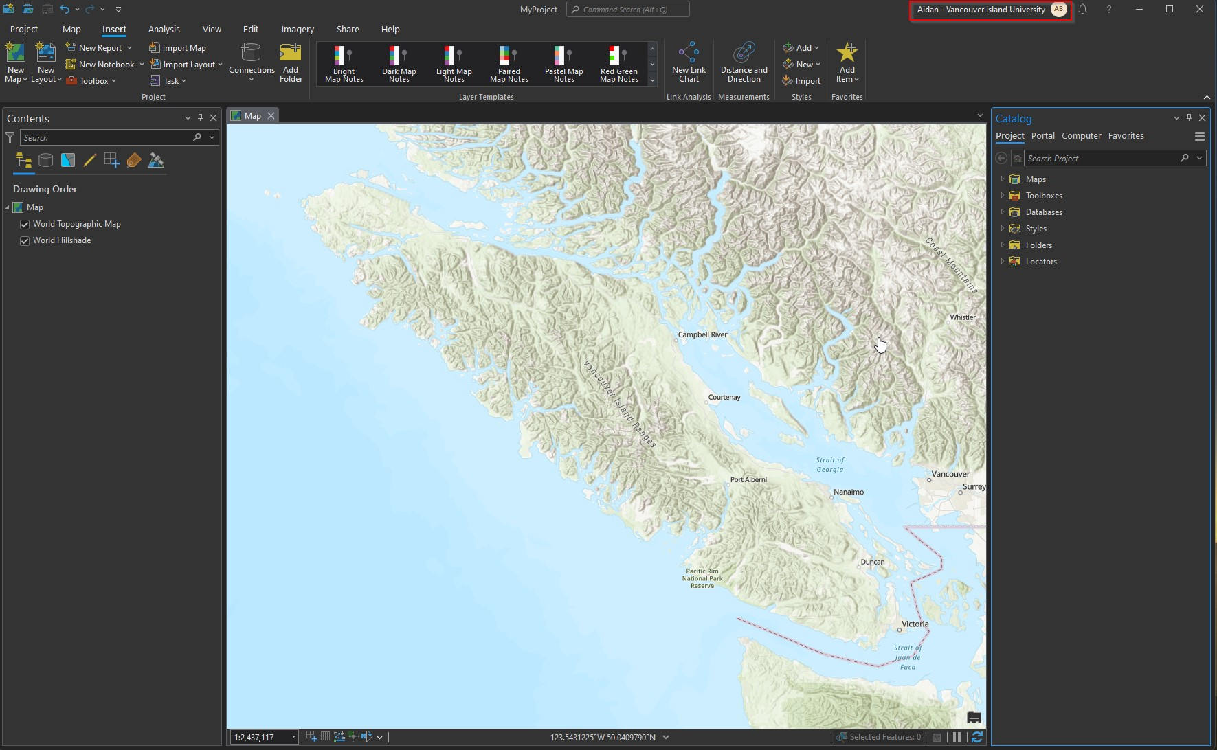

1. Screen capture of the ArcGIS Pro licensing - from within Pro, Project > Licensing. The licensing should show a named user license with an advanced license for Pro and licenses for some of the extensions:

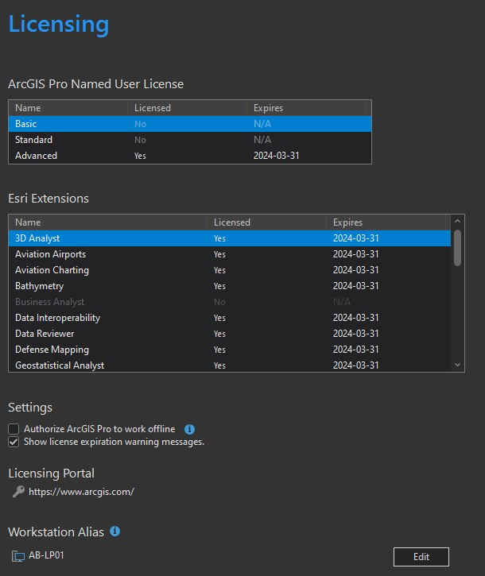

1. Screen capture of the ArcGIS Pro interface on Catala - Programs > ArcGIS > ArcGIS Pro. Just an empty project will suffice, but make sure your login credentials are shown in the top-right corner:

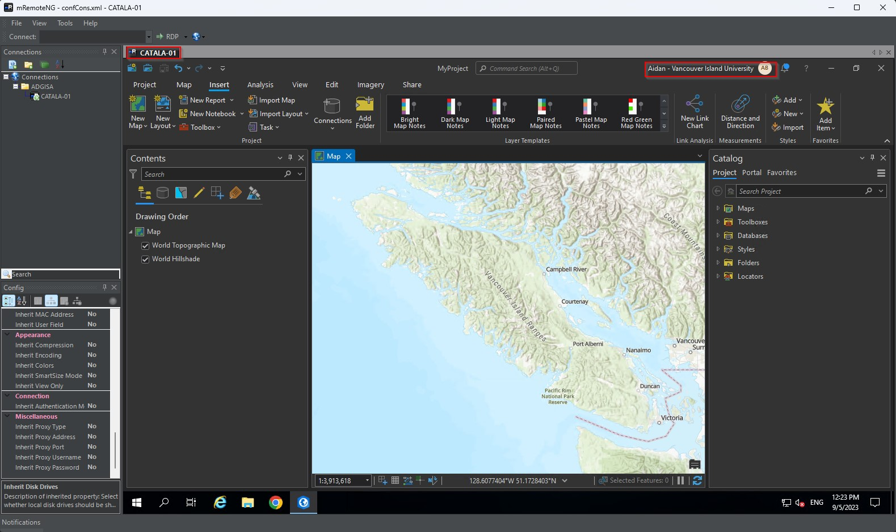

1. Screen capture of the mapped drives on Catala - establish a remote desktop connection to Catala, go to File Explorer and show the various drives (network locations) you are now connected to: U and V:

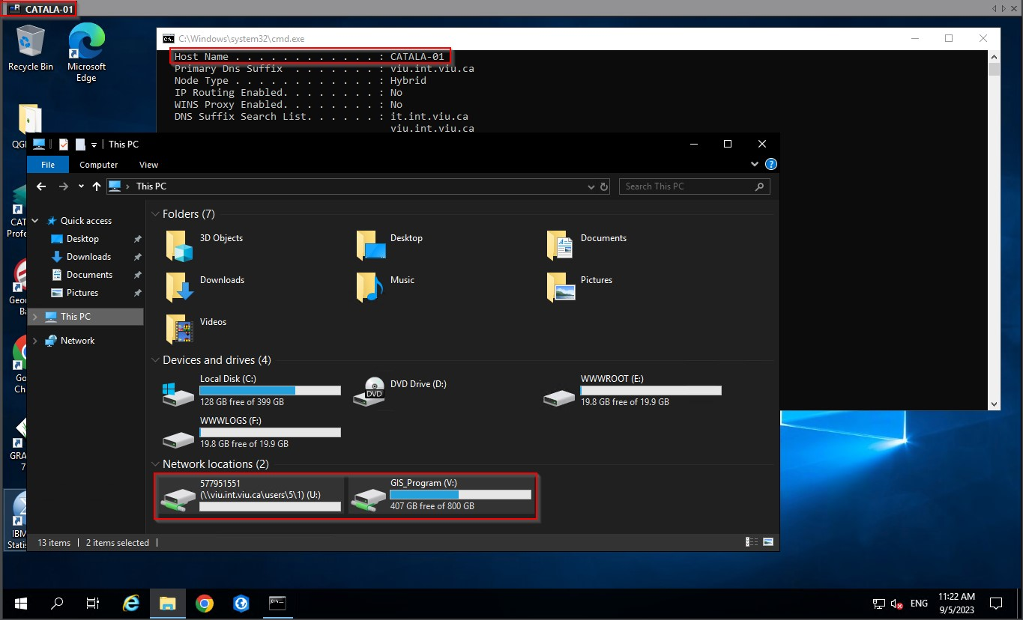

1. Screen capture of Esri Training (<https://www.esri.com/training>)- any page will do, but make sure your profile summary shows in the foreground by clicking on the user icon in the topright corner:

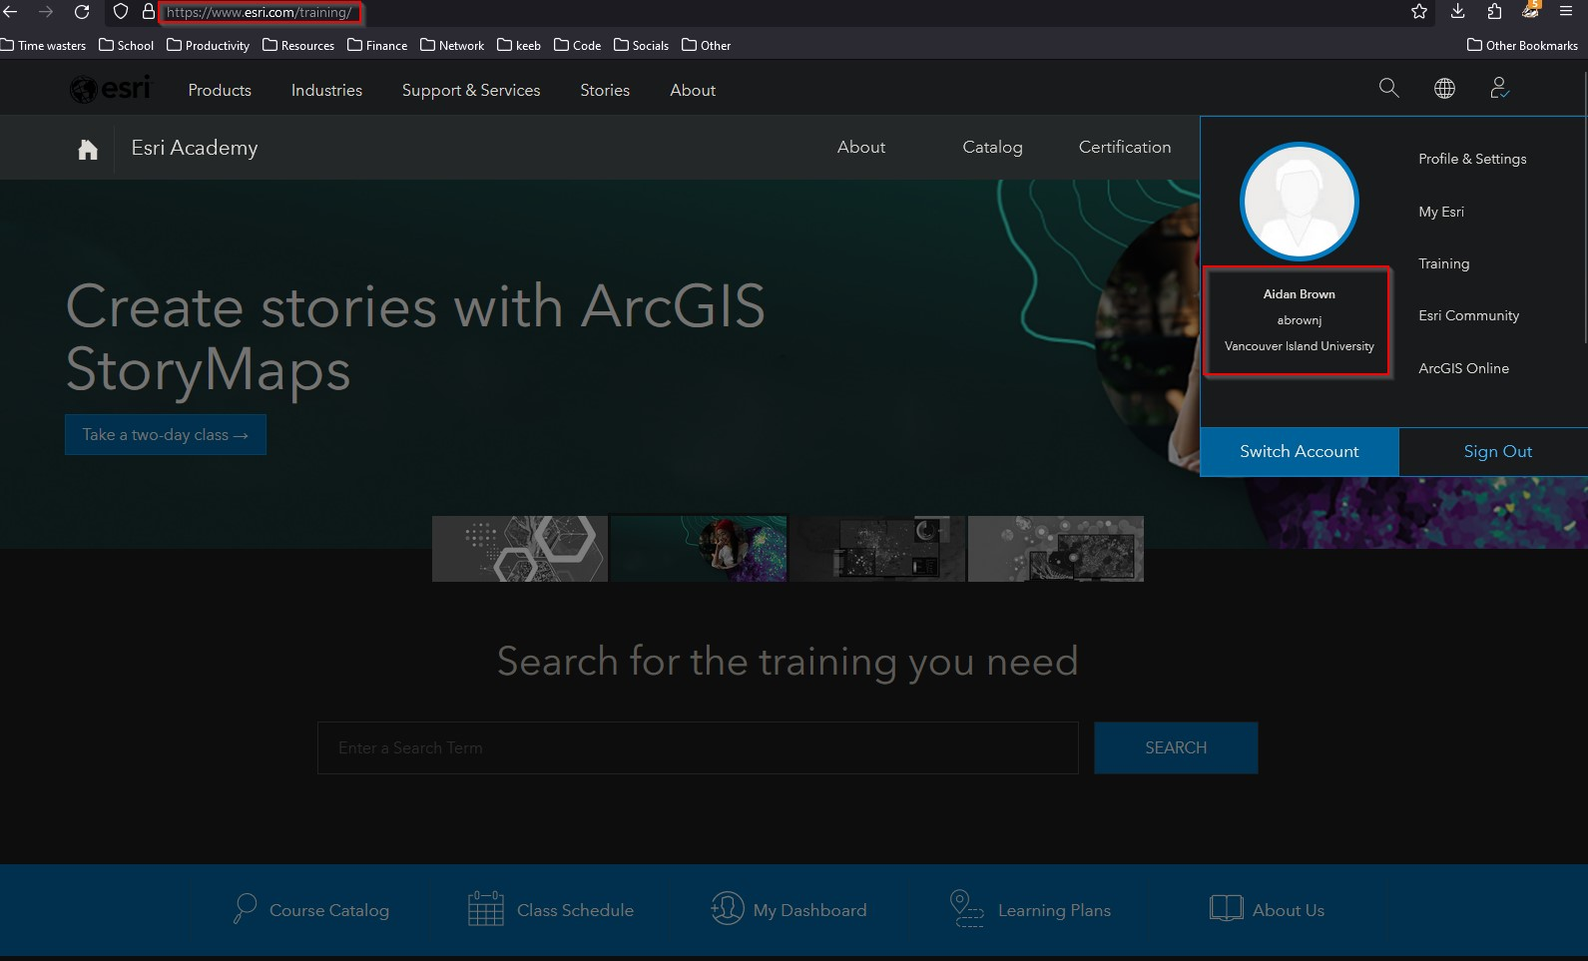

1. Screen capture of ArcGIS Online ([https://www.arcgis.com)](https://www.arcgis.com/) - any page will do, but make sure your profile summary shows in the foreground by clicking on the user icon in the topright corner:

